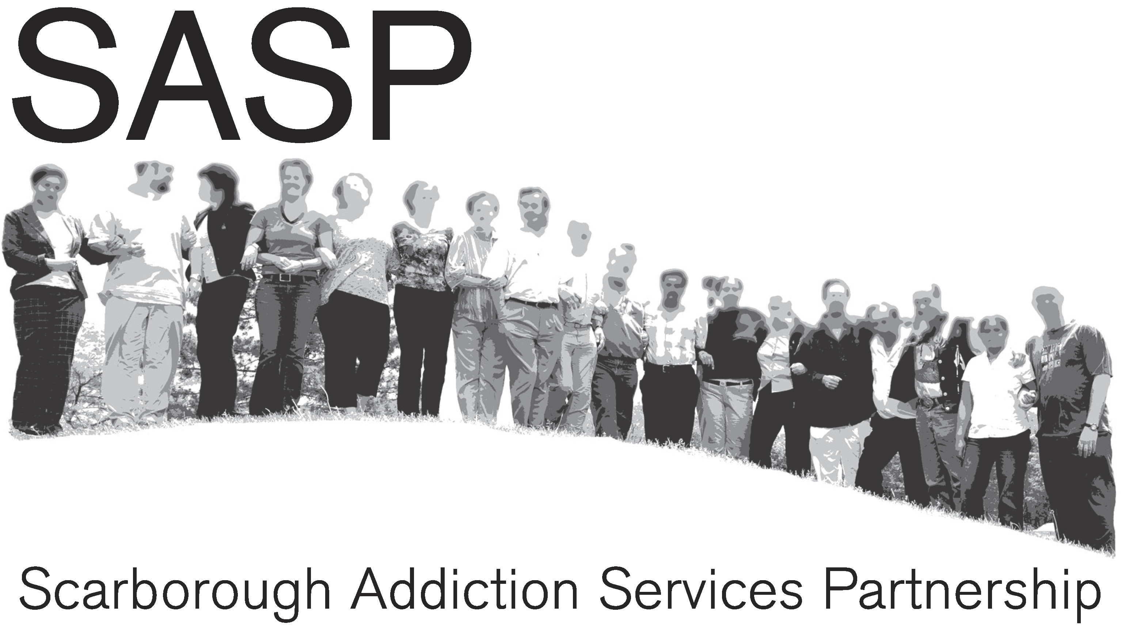 | Scarborough Addictions Service & Capacity Building  Grant Application  2012-13

Section A: Organizational Information

Organization Name | POR AMOR
Address | 46 Long Drive  Whitby, Ontario  L1N 8E4
Mailing Address
(if different from above)

Website Address | www.poramor.ca
Contact for Contract matters | Name
Contact for Contract matters | Title
Contact for Contract matters | Phone
Contact for Contract matters | E-mail
Contact for Contract matters | Fax
Charitable Registration #
GST Registration #
Date organization established
Organization’s corporate name (if different from above)
Description of organization’s mandate (may attach brochures)
Level (amount of insurance carried)  (note: the usual CAMH requirement for programs is $5 mil liability and $2 mil automobile, but the nature of the work being done is considered) | Comprehensive Liability
 | Professional Liability
 | Automobile (if used for program delivery
Has your organization been funded through SASP before? | Yes  No | If yes, when and for what purpose?
Other than SASP, have you been funded through or partnered with CAMH before? | Yes  No | If yes, when and for what purpose?

Section B: Project Overview

Contact for Project/Program (if different from organization contact in section A) | Name | Tanika Riley
 | Title | Program Director
 | Phone | (905) 626-1773
 | E-mail | tanika@poramor.ca
 | Fax | (905) 665-8461 call ahead first
Project Name | Rites of Passage
Amount Requested  (max. $30,000 first yr) | $30,000.00
Area(s) of focus  (see RFP)  Check all that apply | Addictions Treatment Services  Outreach to Clients/Potential Clients  Harm Reduction Services  Culturally-specific services  Engagement with under-served/priority populations  Activity in under-served/priority neighbourhoods  Strengthening staff addictions capacity/competencies  Partnerships/capacity building with Primary Health Care services  Partnering/networking initiatives to better serve clients  Increase in community awareness and/or de-stigmatization  Reducing barriers to addiction treatment/services  Other (please describe – note that the above are preferences)  Process to support young people into the stages of adulthood
Please describe your project below in 250 words or less  (note – to check number of words in MS Word –click on Tools and Word Count for total words) | Rites of Passage are a traditional Indigenous process focused on assisting young people as they transition from adolescence to responsible adulthood. The overall goal of our Rites of Passage process is to provide young women and men of African Heritage with skills and knowledge that will enable them to prepare themselves, culturally, mentally, spiritually, physically and emotionally for successful passage into responsible manhood and womanhood. Rites of Passage helps youth of African descent reconnect with important principles that are part of their African Heritage. Rites of Passage enable youth to ask the questions; Who am I ( Personal Identity), Who have I been ( Reflection), What is my purpose (Vision) and Who am I becoming (Future Goals). POR AMOR's Rites of Passage process uses the eight principals of the Nguzo Nane; Unity, Self-Determination, Collective Work and Responsibility, Cooperative Economics, Purpose, Creativity, Faith and Respect as the framework for our curriculum. All teaching tools such as workshops, field trips,dialogue circles and readings will serve to further enhance the youths understanding of these principals. POR AMOR also uses the methodology of Educate, Create and Activate, whereby all youth in the Rites Process, will learn about the above fundamental principals (Educate), will create an artistic piece based on each principal (Create) and finally put those experiences into collective action (Activate). The holistic nature of the process is believed to decrease the chances of young people engaging in harmful behaviours especially with drugs and alcohol. The process runs for 27 weeks,once a week after school and some weekends.
Section C: Project Details

1 | Who will you reach?  (include age, gender, culture, language) | Young men and women of African- Canadian decent ages 13-18.
2 | What area/s of Scarborough will you reach? | Orton Park- Lawrence Malvern  Kingston-Galloway
3 | How many people are you planning to reach through the project? | Twenty youth
4 | What specific issues are you planning to address? | Low Self-Esteem  Lack of Spiritual Foundation  Harm Reduction and Addictions  Racism, Peer Pressure , Violence  Materialistic Worldview  Poor Health , Stress , Self-Centered  Lack of community engagement  Lack of Proper Role Models  Lack of Vision for the Future
5 | Indicate the methods you will use to reach/serve your target group (e.g. individual sessions, groups, media, outreach, training sessions): | Reach target group; Outreach to our community allies such as Native Child, Storefront, The Boys and Girls Club of East Scarborough, TAIBU, Cedarbrae Collegiate, Apple- Expelled program TCDSB and past  POR AMOR program participants.  Serve Target Group;  Dialogue Circles  Music  DVD's (Documentaries etc)  Theater  Creative projects  Elder Teachings  Workshops  Field trips (Health Food Store, Elder Homes, Cultural book stores etc)  Cultural festivals (Afro Fest, Drumming Festival)  Research project  Reading and book list  Weekend Retreats  Nature Activities  Library - must have a library card  Cultural bookstores  Naming Ceremony
6 | Do you already have a working relationship with your target group? If so, please describe. | Yes, POR AMOR has been active in the East Scarborough community with a focus on youth programming for 6 years. We have worked with all of the other community agencies in the area to serve youth in the community and to share our knowledge, resources and best practices. Due to our previous youth programs with have a extensive relationship with our past youth participants and there friends
7 | What information do you have that backs up the need for this project? | See notes
8 | Have you consulted any stakeholders/agencies regarding this project? (if so, who and by what method? If not, why?) | We have contacted WoodGreen via a ph meeting  Contacted Storefront/Action for Neighbourhood Change via ph call.
9 | What are your current partnerships that will assist you in carrying out this project? | TAIBU, Centennial College,The Boys and Girls Club of East Scarborough, Native Child and Family Services
10 | What partnerships are you hoping to develop through this project? | We are hoping to work more closely with TAIBU to create a effective rites program that can become a core program for their organization. We would like to work with WoodGreen who has their own rites program for the last five years to share resources and community volunteers. We are looking to build with teachers at Cedarbrae Collegiate Institute and Apple- expelled program in TCDSB
11 | If you are hiring or re-deploying staff for this project, describe the qualifications you will require for staffing. | We are hiring workshop facilitators, for workshops in drumming, holistic health, yoga, elder teachings etc. The qualifications the consultants must have are experience working with youth within a cultural context, knowledge of youth issues from at risk neighborhoods, experience in rites programs.
12 | If clinical work is involved, how will you provide clinical supervision to staff? | N/A
13 | Have you provided addiction services before? If so, provide a brief description. | TAIBU blurb
14 | How will you address access barriers? (e.g. mobility, disabilities, language, child care, transportation, etc.) | The facilities we are using are wheelchair accessible and they also have care child available. We are allocating in the budget for TTC tickets for those youth who require transportation support.
15 | Explain why your agency is interested and how you are qualified to carry out this project. (100 words or less) | POR AMOR's experience working with youth, taught us what elements of youth programs are effective and what elements do not lead to sustained change. Our Youth 4 Human Writes program which has elements of Rites demonstrated how meaningful and powerful program like these are in creating a fundamental shift in how young people view themselves and the world around them. We believe in the process of Rites and our communities need for this missing stage in our youths development. Our program director participated in a Rites program and through that experience built community allies and partnerships with others creating and facilitating Rites programs in Toronto.
16 | If you receive the grant, what supports would you hope SASP would be able to provide? | Provide workshops on addictions and getting support for addictions. Have any clients that are willing to share their stories as elders with the youth regarding their journey through addictions and/or mental health so are youth can learn from them and avoid making the same mistakes.
17 | Please indicate if you will be applying for 2nd and/or 3rd year funding? If so, please give a very brief overview of your goals and objectives for year two and/or three. (200 words or less) | POR AMOR will be applying for 2nd and 3rd year funding.  Vision year two;  - Apply for additional funding to expand scope of Rites program  - Take on ten new youth to participate in “Rites of Passage”  - Maintain relationships built with first group of twenty initiates in two ways;  - Having half of the first year rites initiates assist in the mentoring of the new group of initiatives  - Having first year group assist in the organizing of workshops and activities.  - Having ten of first year initiates par-take in service learning trip within Canada or the Dominican Republic ( POR AMOR has experience facilitating these trips) to further there growth and to apply community building skills learnt.  Vision year three ;  - Apply for additional funding to expand scope of Rites program  - With additional funding and staff ,take on twenty new youth to participate in “Rites”  - Having first and second year group assist in organizing of workshops & activities.  - Having the second year initiates par-take on a service learning trip either within Canada or the Dominican Republic ( POR AMOR has experience facilitating these trips) to further there growth and to apply community building skills learnt.  - Support first year initiates in creating opportunities that adhere to their life plans and vision boards

Goals and Objectives for RITES of PASSAGE

List 3-5 Goals/Objectives for year one | List Activities you will engage in to accomplish each goal | Indicate timing for each activity | How will you know if you have accomplished your goals? How will you measure your accomplishments?
1.  To formally recognizes a boy’s/girl’s transition into  responsible adulthood | - Youth participate in “graduation” ceremony with mentors, elders and parents to official welcome them in to the community as adults.  - Youth are given a  Day Name/Spirit Name | - November 2012 | - Graduation ceremony organized with all stakeholders invited (family, friends, mentors, elders etc)  - Number of stakeholders in attendance (sign in sheet)
2  To increase youths connection to the sacredness of nature and their balance within nature | - Youth receive teachings from elders/mentors in nature regarding the interconnectedness of nature  - Youth participate in two weekend retreats in nature  - Youth conduct team and individual activities within nature | - May- Oct 2012  - May & Oct  - May- Oct 201 | - Group/Individual observations within nature and attitude to nature  - Two weekend retreats are organized and attended well  - Nature based activities are created and facilitated minimum of twice/month  - Arts based evaluation techniques- creative pieces made  - Surveys (beginning, middle and end)  - Video Testimonials  - Responses to questions asked in weekly “Sharing Circles”
3.  To increase a young persons development in goal setting, visioning and life skills | - Workshops in communication, economics ( 8 principals pg 4) etc.  - Youth create a vision board  - Youth create a life plan | - May- Oct 2012  - August 2012  - September 2012 | - % of participant’s completion of vision board and life plans  - Quality of vision boards and life plans  - Level of participation in workshops
4.  To provide African-Canadian youth with a deeper connection to their history, culture and traditions | - Youth watch media relating to African history, African historical figures  - Youth par-take in traditional teachings, cultural ceremonies and traditions  - Youth participate in weekly Sharing Circles  - Required readings on identified topics  - Youth Retreats | - May- Oct 2012  - May & Oct 2012 | - Group/Individual observations during ceremonies  - Two weekend retreats are organized and attended well  - Arts based evaluation techniques- creative pieces made  - Surveys (beginning, middle and end)  - Video Testimonials  - Responses to questions asked in weekly “Sharing Circles  - Feedback from retreats and ceremonies
5.

Section C Budget

Please complete the following:

Expense Item | Total Cost  (Include in-kind) | Costs covered outside of SASP funding (include in-kind) |  | Funds Requested from SASP
 |  | Source | Amount
Project Coordinator  20 hrs/week for 12 weeks @ $27  12 hrs/ week for 27 weeks @$27 | $15,228.00 | POR AMOR | $228.00 | $15,000.00
Volunteer Coordinator  15 hrs/week for 5 weeks @$20  5 hrs/week for 25 weeks @$20 | $4,100.00 |  |  | $4,100.00
Workshop Facilitators | $3,500.00 |  |  | $3,500.00
Retreats x2 & Field Trips | $3,000.00 |  |  | $3,000.00
TTC Tickets | $600.00 |  |  | $600.00
Refreshments | $1,000.00 |  |  | $1,000.00
Program Supplies | $1,500.00 |  |  | $1,500.00
Volunteer Expenses | $1,000.00 |  |  | $1,000.00
Documentation | $300.00 |  |  | $300.00
Promotion & Advertising | $800.00 | TAIBU CHC | $800.00
Equipment –  (camcorders, computers, camera's) | $4500 | TAIBU CHC | $4,500.00
Graduation Ceremony | $472.00 | POR AMOR | $472.00
TOTAL | $36,000.00 |  |  | $30,000.00

Section D: Authorization & Submission Instructions

A signing officer of your organization must sign this application.
(In cases of a Trustee, signing officer of the Trustee’s organization must also sign)

I/we certify that I/we are authorized to sign this application of behalf of (provide name of the organization). We understand that, if approved:

- our contract will be with the Centre for Addiction and Mental Health
- a representative of our organization will be required to attend monthly SASP meetings
- we will be required to make timely reports on our progress on a quarterly basis
- we may be subject to a program evaluation process
- we may be asked to share progress reports and materials with other SASP members
- work will need to be completed between April 1, 2010 and March 31, 2011

Name (Print or Type) | Signature | Position | Date

Name (Print or Type) | Signature | Position | Date

Deadline: Monday, November 28, 2011 at 2:00 pm
(Late applications will not be accepted)

Format: 1 e-mailed copy (received before the deadline and please be mindful that some internet servers may hold documents therefore please give yourself ample time), 1 original (can be received after the deadline by mail)

E-mail to: Tammy_mackenzie@camh.net

Mail/deliver to: Tammy MacKenzie
33 Russell Street, 3rd floor
Toronto, ON M5S 2S1

For inquiries or assistance, please contact:
Tammy MacKenzie
Tammy_mackenzie@camh.net
647 221-2650 mobile
416 535-8501 ext. 3940

